## Migracion.2.SUI módulos. datos Control interno

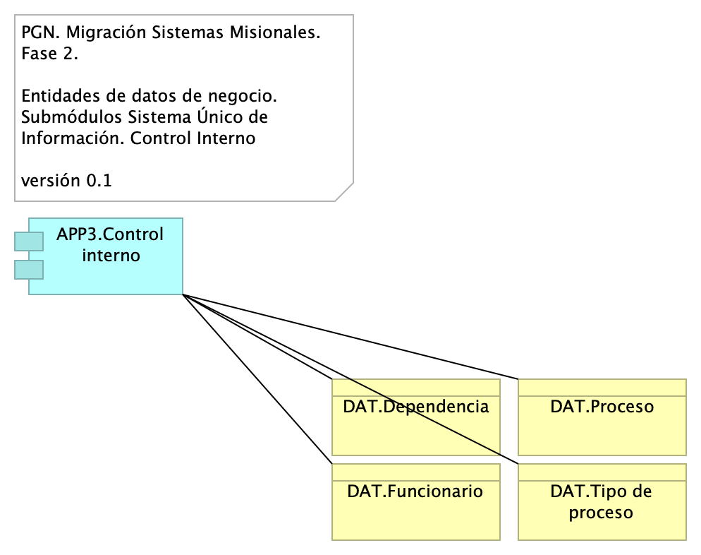

Figure 1: Diagram: Migracion.2.SUI módulos. datos Control interno

### Catálogo de Elementos

| Name | Type | Description | Properties |
| --- | --- | --- | --- |
| **APP3.Control interno** | application-component |  |  |
| **DAT.Dependencia** | business-object |  |  |
| **DAT.Funcionario** | business-object |  |  |
| **DAT.Proceso** | business-object |  |  |
| **DAT.Tipo de proceso** | business-object |  |  |